5th August 2020

Hodson Bay Celtic FC Return to Training/Playing Protocol
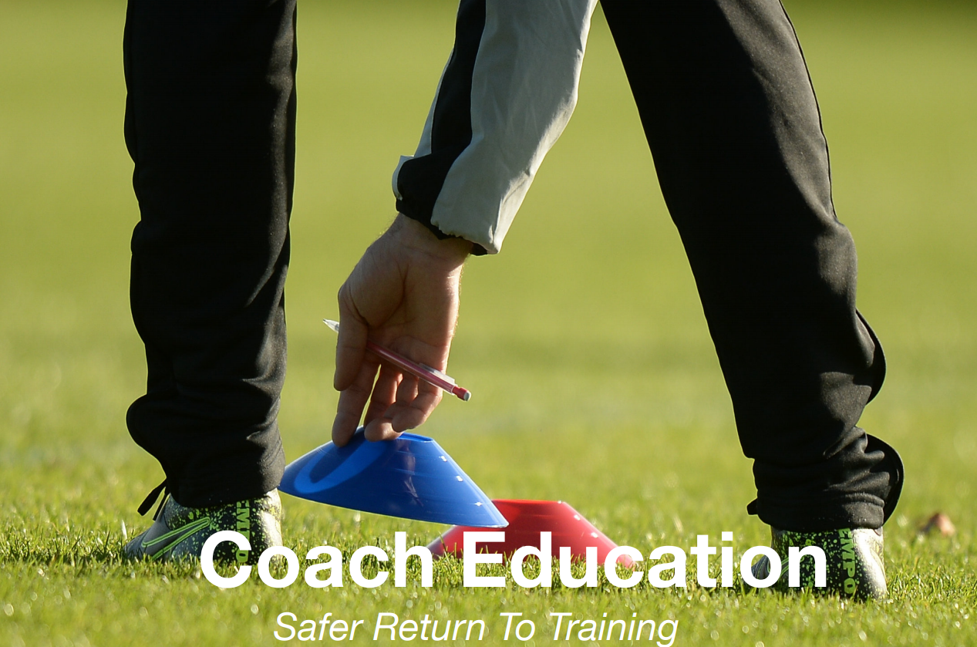
Hodson Bay Celtic FC Return to Training Protocol based on FAI Safer Return to Training Protocol

The status of the current COVID -19 pandemic remains a dynamic and evolving situation. The purpose of Hodson Bay Celtic Protocol is to outline the necessary measures which are required to take place before, during and after training.
These measures are not exhaustive, but are aimed at risk minimisation of COVID -19 amongst our members and those who utilise our facilities, which remains a club priority to ensure a return to training that is both safe and sustainable.
This Protocol will, at all times, be guided by Government, FAI and Public Health Policy in particular:

- FAI Safer Return To Training Protocol (2nd edition);
- HSE COVID 19 Interim recommendations for the return to spots activities for children and adolescents;
- Hodson Bay Celtic Safer Return to Training COVID 19 Risk Assessment.

This Protocol will remain under monthly review, or at a lesser interval, as the case may be, by Hodson Bay Celtic Committee as Government, FAI and Public Health Policy evolves to the pandemic.

- Coach Responsibilities
- All coaches must be familiar with the FAI Safer Return to Training Protocol.
- All coaches must be familiar with Hodson Bay Celtic Protocol.
- All coaches shall certify that they are familiar with the FAI Safer Return to Training Protocol and Hodson Bay Celtic Protocol with designated members of the Hodson Bay Committee before returning to training.
- All coaches will provide a list of designated coaching assistants to the Hodson Bay Celtic committee before commencement of training.
- All coaches will notify the Hodson Bay Celtic committee in circumstances where the designated coaching assistant list is altered or changed.
- All coaches will note that ONLY designated coaching assistants can assist in training.
- All coaches must ensure that all participants and designated assistants in coaching practices are briefed on the FAI Safer Return to Training Protocol and Hodson Bay Celtic Protocol.

Before You Coach

You must stay at home if you:
- Have been in contact with someone with COVID-19 or a suspected COVID-19 case in the last 14 days.
- Have been overseas, to a location that is not on the COVID-19 Green List, or exposed to someone with COVID-19 in the last 14 days.
- Have flu like symptoms or are feeling unwell.
- Have a temperature of 38C or more.
- Experience the sudden onset of a cough or a shortness of breath.
- Experience a sudden loss of sense of taste and smell.

You must:
- Check with your GP if you are in a high-risk health category and ask if you are medically fit to coach.
- Familiarise yourself with club COVID-19 safety protocols.
- Ensure club has up to date contact details.
- If you have additional concerns due to underlying medical conditions or are living with people with underlying conditions - please discuss the concerns with Hodson Bay Celtic COVID-19 Compliance Officer as part of HBC continued analysis of risk.
- Please ensure you have clarified that it is safe for you to return.
- Notify any member of Hodson Bay Celtic Committee and /or the Hodson Bay Celtic COVID -19 Compliance Officer.

Training Sessions
- Hodson Bay Celtic committee will schedule a 15 minutes gap between training sessions to facilitate a safe and socially distancing change over between teams and coaches.
- Please respect this scheduling.
- All activities will take place on the astro turf or grass pitch.
- Players, coaches and designated assistants practice good coughing and sneezing etiquette.
- Coaches and designated assistants ensure use of hand sanitiser located at the entrance of each training zone at astro and/or grass pitch
- Meetings taking place on astro turf or pitch take no longer than 10 minutes and adhere to social distancing guidelines.
- Coaches and designated assistants must arrive to the session in their training gear.
- Coaches must ensure that only coaches and pre-designated assistants occupy the training zone on the astro facility and/or grass pitch at all times throughout each training session.
- Coaches must record a register of attendances at all training sessions to and have available for the Hodson Bay Celtic’s COVID-19 Compliance Officer.
- Coaches must ensure that the coaching area and pitch is clear of all equipment before leaving the facility.
- Coaches will ensure that they have in their possession a 2 litre spray bottle of sterilising fluid, which will be provided by Hodson Bay Celtic.
- Coaches must ensure that all equipment and balls are sanitised before and after training.
- Coaches must have in their possession one set of gloves and mask in case of treatment of an injured player.

- Player and Parent/Guardian Responsibilities
- All Parents/Guardians must be familiar with the FAI Safer Return to Training Protocols and Hodson Bay Celtic Protocol.
- A Hodson Bay Celtic COVID -19 Health Questionnaire will be provided via your coach and /or accessible on the Hodson Bay Celtic website.
- The Hodson Bay Celtic COVID-19 Health Questionnaire must be completed and submitted prior to players being permitted to commence training with Hodson Bay Celtic.
- Any change in respect of the information submitted as part of the Hodson Bay Celtic COVID -19 Health questionnaire must be notified to your coach and/ or any member of the Hodson Bay Celtic Committee or the Club’s COVID 19 compliance officer.
- The Hodson Bay Celtic COVID -19 Health questionnaire will be reviewed by the Hodson Bay Celtic Committee and may be required to be updated and/ or re-confirmed throughout the playing season, or at such shorter intervals as the pandemic situation evolves.
- All players will be briefed by their respective coaches prior to commencement of training on the Hodson Bay Celtic Protocol.
- Underage players must be dropped off by a member of the same household.
- Players and parents/guardians must not remain at training venue unless a designated assistant with the coaching team.
- Parents/Guardians must remain outside the perimeter of the astro and/or grass pitch training zones.
- Parents/Guardians must not enter the club house.
- Players must arrive in their training gear with their own equipment including their own water (ideally labelled) and goalkeepers bring their own gloves.
- Players sanitise their hands prior to training and use sanitiser on entry to training grounds
- Personal items must be labelled and not shared.
- Player must bring all personal items home with them.
- There will be a designated toilet facility in the club house for the players ONLY.
- Players and parents/guardians are advised to keep up to date with HSE guidelines via hse.ie/coronavirus and Hodson Bay Celtic Protocol as may be amended or updated on the club’s webpage.

You must stay at home if you:
- Have been in contact with someone with COVID-19 or a suspected COVID-19 case in the last 14 days.
- Have been overseas, to a location that is not on the COVID-19 Green List, or exposed to someone with COVID-19 in the last 14 days.
- Have flu like symptoms or are feeling unwell.
- Have a temperature of 38C or more.
- Experience the sudden onset of a cough or a shortness of breath.
- Experience a sudden loss of sense of taste and smell.

You must:
- Check with your family GP.
- Familiarise yourself with club COVID-19 safety protocols
- Ensure club has your up to date contact details
- If you have additional concerns due to underlying medical conditions or are living with people with underlying conditions - please discuss the concerns with club COVID-19 Compliance Officer as part of your clubs’ risk assessment
- Please ensure you have clarified that it is safe for you to return

- Player Welfare
- Players in need of attention are treated on the training area, ideally the coach wears gloves and a mask
- The Hodson Bay Celtic clubhouse may be opened as a designated area to deal with an injured player
- A player suspected of a new onset of COVID-19 must be provided a face mask and isolated with immediate contact made with parent/guardian

- Hodson Bay Celtic COVID-19 Compliance Officer Role and Responsibilities

- Training to commence in line with the FAI Safer Return to Training Protocol post submission of the COVID-19 checklist to the FAI.
- Hodson Bay Celtic FC’s “COVID-19 Compliance Office must be a club member and Garda Vetting with completed Safeguarding 1 training.
- This person’s role will be to attend and observe the training sessions, keep a record of attendees at training sessions for contact tracing purposes, and liaise with the Coaches and Club Chairperson on the processes and procedures around the training facility and training session content.
- This person should be familiar with the Government, Department of Health, and Public Health Policies in relation to COVID-19.

Role and Responsibilities

Training Venue, Facilities and Equipment
- Ensure that a COVID-19 Risk Assessment is carried out on the training venue prior to its use.
- Ensure that COVID-19 signage is visible throughout the training facility.
- Ensure that no changing rooms or showers are used.
- Ensure that sanitary facilities are accessible for players and coaches.
- Ensure that all training equipment, including goalposts are sanitized before and after every training session.

The Training Sessions
- Ensure that the group numbers specified in the FAI Safer Return to Training Protocol are
adhered to:
  - Underage Training | Group of 15 (13 players & minimum of 2 coaches)
- Ensure that only essential personnel access the training pitch/area
- Ensure that the training area is at least 75 X 50 metres in size
- Ensure that social distancing is adhered to by all players and coaches when accessing and leaving the training area
- Ensure contact is kept to a minimum during the training session, as per FAI Safer Return to Training Protocol.
- Ensure players, coaches and parents refrain from congregating at the venue or car park during pick-ups and drop-offs.

Coaches and Players’
- Ensure that the coaches and players understand and adhere to their responsibilities, as set
out in the FAI Safer Return to Training Protocol and Hodson Bay Celtic Protocol.
- Ensure coaches maintain an accessible record of attendees at all training sessions for contact tracing purposes.

Reporting
- Liaise with, and report to, the Club Chairperson and relevant coach(es) regarding the training sessions and adherence to the FAI Safer Return to Training Protocol.

Approved by the Hodson Bay Committee on the 5th August 2020.

